1. Purpose
Provide a single transaction for creating, changing, displaying and reporting CER (Capital Expenditure Request) Proposals, routing them through a multi-level approval workflow, keeping a field-level audit trail, and producing PDF/Excel outputs.
2. Business Objectives
- Capture all CER details (project, financials, JV alignment, phasing, cost breakdown, remarks) in one place.
- Automatically start an approval workflow on create and change.
- Track every change to a proposal with old value, new value, user, date and time.
- Let users download a proposal as a PDF form or an Excel-compatible file.
3. Users / Roles
Role | Activity
CER Owner / Initiator | Create and change proposals, trigger workflow
Approvers | Approve via workflow; view approval levels (screen 0300)
Finance / Audit | Display, report, audit log
Key fields : CERPRNO, PR_NAME, OWNAME, STATUS, OBJECT, AMOUNT, CAT, PAYABLE, PERIOD, BEN_NPV, BEN_IRR, COST, ST_DATE, COM_DATE, DURATION, CBUDGET, CB_AMNT, CB_CURRENCY, REASON, JV, JV_COST, JV_BUDGET, JV_AMNT, JV_REASON, phasing labels (PH_TILL, PH_FY, PH_BEYOND), PROD / CAPEX / OPEX (each with current, _23 and _B buckets), ENGINEER, S_FAC, COMIS, PREOP, OTHERS, TOTAL, REMARKS, REMARKS_JV, plus technical fields (CREATED_DATE, CREATED_BY, CHANGE_IND, USRID, COMP_APPR_LEVEL, APPROVE).

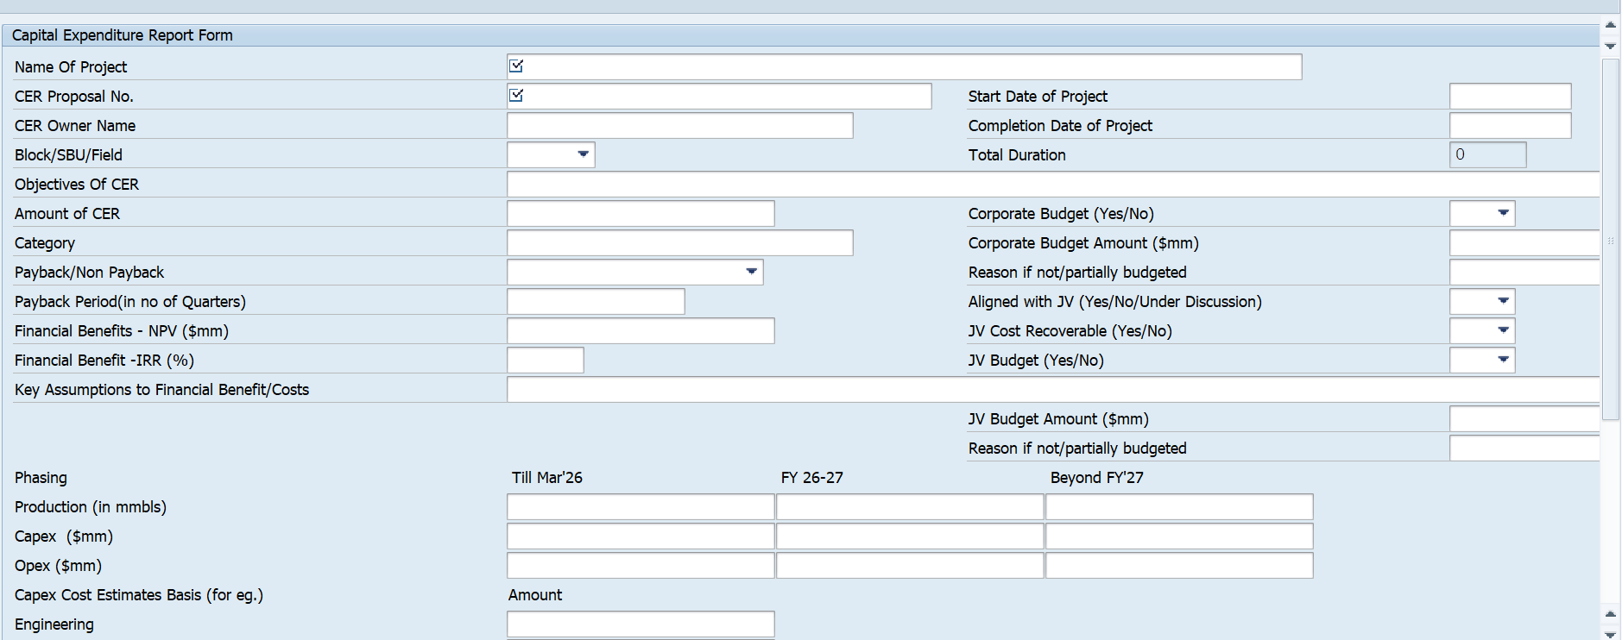
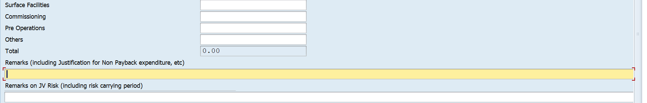
5. Selection Screen
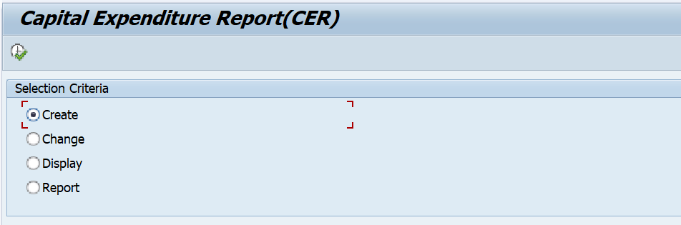
6. Functional Requirements
FR-01 Create CER
- Start of selection and opens the creation screen
- On save, a proposal number is generated (logic in include, to confirm)
- After save, the workflow is triggered (FR-05). Success message: "CER Proposal No. has been created and sent for approval".
FR-02 Change CER
- Proposal number is mandatory. If blank, show status message "Make an entry in mandatory field 'CER Proposal No.'" (success type, displayed as error).
- On save, compare old vs new (FR-06), then re-trigger the workflow. Message: "... has been changed and sent for approval".
FR-03 Display CER
- Display the proposal no.
FR-04 Report
- Report showing details of CER proposal.
Format attached
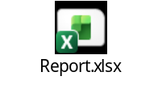
FR-05 Approval Workflow
- Approval Workflow via Email
The approval workflow should be executed through email, with all relevant attachments included.
- Workflow Email Visibility
Workflow emails with attachments should also be marked to:
  - The creator
  - All previous approvers
  - The next level approver
(Aligned with the contract closure workflow pattern)

FR-06 Change History (Audit Trail)
- compares every field of the old and new structures dynamically (RTTI).
- Field description rules:
  - REMARKS: fixed text "Remarks (including Justification for Non Payback expenditure, etc)".
  - PROD, CAPEX, OPEX: DDIC long label + PH_TILL.
  - _23 variants: label + PH_FY. _B variants: label + PH_BEYOND.
  - All others: DDIC field text.
FR-07 Audit Log Display
- DISPLAY_AUDITLOG reads all audit rows for a proposal, sorted by proposal, date, time.
- ALV grid columns: CER Proposal No., Field Description, Old Value, New Value, Date, Time, User Name. Zebra layout, optimized widths, layout saving enabled.
- For REMARKS and REMARKS_JV rows, old/new values show an icon with "Display Text". Double-click opens popup screen 0400 with the full long text.
- If no rows exist: "No Data found".
FR-08 Remarks Long Text
- A custom container REMARKS hosts a text editor (wrap at position 90, no toolbar, no status bar).
- Load: Find all texts in STXH named <CERPRNO>% (object ZCER_TEXT, ID ZCER, logon language). Take the latest version (descending name sort) and read it with READ_TEXT.
- Save: Only when the editor content was modified, save a new text version named <CERPRNO><date><time> using SAVE_TEXT. This preserves history of remarks.
FR-09 PDF Download
- DOWNLOAD_PDF opens a job, generates the Adobe form ZFI_CER_FORM for the proposal, converts the PDF to binary, saves it on the frontend as <CERPRNO>_<date>_<time>, and opens it.
- If no PDF is produced: "Error while generating PDF file".
FR-10 Excel Download
- DOWNLOAD_EXCEL reads the proposal, lets the user choose a path (default extension xls), and downloads a tab-separated file with a header row of business-friendly column titles (e.g. "Amount of CER", "Payback/Non Payback", "Financial Benefits - NPV ($mm)").
- If the user cancels: information message "Download cancelled". If no data: "No Data found".
7. Non-Functional Requirements
- Authorization: Authority checks per activity (create/change/display/report) are not visible in this program and should be added or confirmed.
- Usability: Errors are shown as status messages so the user stays on the selection screen.
- Auditability: All changes after initial creation are recorded with user and timestamp.
- Output: PDF through Adobe Forms; Excel-compatible text file.
8. Findings and Recommended Improvements
# | - Editable CER Proposal Number  The CER proposal number should be editable in the system.  - CER Number Carry-Forward (C/F)  The carry-forward option for CER numbers will be automatically addressed once editability of the proposal number is enabled.  - Approval Workflow via Email  The approval workflow should be executed through email, with all relevant attachments included.  - Workflow Email Visibility  Workflow emails with attachments should also be marked to:  - The creator  - All previous approvers  - The next level approver  (Aligned with the contract closure workflow pattern)  - Download Options  Provision to download the CER form in both PDF and Excel formats should be available.  - Audit Trail  A complete audit trail should be maintained, capturing all changes and approvals.  - Post-Approval Revision  The CER form should allow revision even after final approval; however, the CER proposal number must remain unchanged.  - Multiple Attachments  The CER form should allow multiple attachments with support for all file types.  - SBU Field Modification  - Rename RJ Oil & Gas to RJ North and RJ South  - Remove RJ01 option  - Multiple Creators  The system should allow multiple creators within the organization.  - Flexible Approval Hierarchy  Provision for addition or deletion of approval levels in the workflow should be available.  - Category Dropdown  CER form should have a dropdown with the following categories:  - Essential  - Vital  - Desirable  - Remarks Field Limitation  Remarks (including justification for non-payback expenditure, etc.) should have a word limit of 350–400 words.  14.Attachment Visibility During Approval  At the time of approval, all attachments and details should be clearly visible, similar to the PO approval process.  15.Approval Status Visibility  The display section should clearly indicate at which approval level the CER is currently pending.  At the end of the Form, please add the definition of :
  Category Definition
  Vital- Vital CERs are those which cannot be postponed under any circumstances with or without payback
  Essential- Essential are those which are important for smooth running of the operations and are justified through a short payback period
  Desirable- Desirable are those which can be deferred without impacting operations and generally have a long payback period or no payback period
  10. Acceptance Criteria (summary)
  - A user can create a CER and a workflow item is generated.
  - Changing a proposal writes one audit row per modified field (excluding the technical fields listed).
  - Remarks changes create a new text version and appear in the audit log with a clickable detail view.
  - PDF and Excel downloads work from an existing proposal.
  - Blank proposal number in Change/Display mode is rejected with the specified message.

